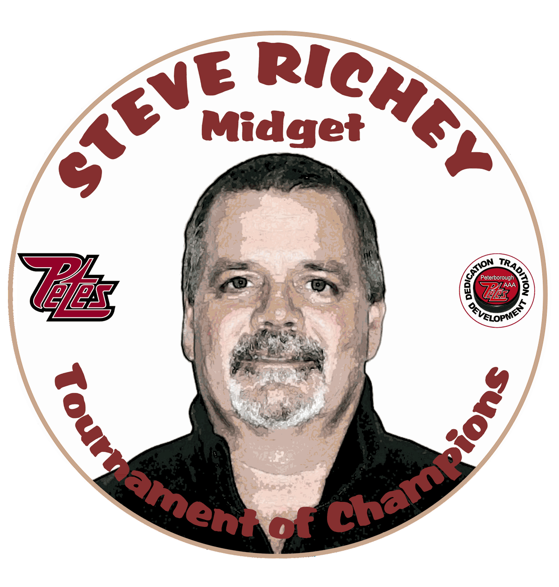

2021-2022 Steve Richey
Tournament of Champions
Peterborough, Ontario
January 13-16, 2022
The "Steve Richey Tournament of Champions" is a premier AAA tournament.
Over the years, many of the top ranked AAA teams from Ontario and the U.S. have competed in this tournament, which will showcase some of the best talent minor hockey has to offer.
Many OHL and Junior Hockey Scouts attend this tournament every year,
which makes it a great opportunity to showcase players in attendance.

PLEASE REGISTER NOW AND JOIN US IN JANUARY
* O.M.H.A. sanctioned ‘AAA’ tournament
* Sponsored by Peterborough Minor Hockey Council
And the Peterborough Lions Club
U16 teams (2006’s)
U18 teams (2004’s AND 2005’S)
* 4 games guaranteed - 7 maximum (U16 - 6 maximum)
* Entry Fee - $ 2350.00
* Scheduling priority- play teams other than in your league
* 3x15 periods for all games.
Floods before and after 2nd period all games.
Top Goalie and Top Scorer awards.
MVP Awards presented in the Championship and Consolation Finals.
U18 teams start round-robin play on Thursday (beginning at 1:00 p.m.).
(U18) Quarter-finals start Saturday evening.
Semifinals and Championship Finals on Sunday.
For more information and registration form please visit the tournament web-site at:
https://peterboroughminorpetes.ca/Tournaments/1523/2021-2022_Steve_Richey_Tournament_of_Champions/
Tournament contact: Michele Leroux - mlleroux@yahoo.com
PMHC Tournament Director: Frank Curran – petestourny@gmail.com

