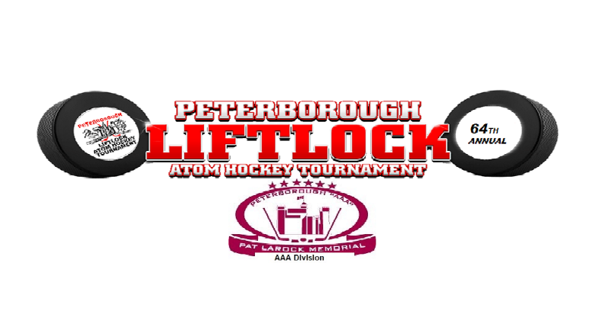
2021-2022 Peterborough Liftlock Atom
Hockey Tournament
Pat Larock Memorial AAA Division

Peterborough, Ontario
January 7-9, 2022
The "Peterborough Liftlock Atom Hockey Tournament" is a premier tournament and now offers the Pat Larock Memorial AAA Division.
Over the years, many of the top ranked AAA teams from Ontario and the U.S. have competed in the Pat larock Memorial Tournament. This tradition will now continue as part of this great tournament, which will showcase some of the best talent minor hockey has to offer.
PLEASE REGISTER NOW AND JOIN US IN JANUARY

* O.M.H.A. sanctioned ‘AAA’ tournament
* Sponsored by the Peterborough Liftlock Atom Hockey Tournament Committee
and the Peterborough Minor Hockey Council

U10 teams (2012’s)
U11 teams (2011’s)

* Entry Fee - $ 1750.00
* 4 games guaranteed - 6 maximum
* Scheduling priority- play teams other than in your league
* 2x10, 1x15 periods for Round-Robin, Semis & Finals.
All teams start Round-Robin play on Friday (beginning at 8:00 a.m.).
Semifinals and Finals are on Sunday.
For more information and registration form please visit the tournament web-site at:
https://peterboroughminorpetes.ca/Tournaments/1562/Forms/5828/2021-2022_Peterborough_Liftlock_Atom_Hockey_Tournament_Pat_Larock_Memorial_AAA_Division_Registration/
Tournament Director: Frank Curran – petestourny@gmail.com

