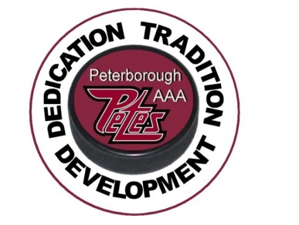

Peterborough Minor Hockey Council

**FOR IMMEDIATE RELEASE**

**Boston Pizza Peterborough Icefest**

**October 18-21, 2018**

October 16, 2018 – The Peterborough Minor Hockey Council (PMHC) is once again honoured to host the 2018 Boston Pizza Icefest “AAA” Tournament from Thursday, October 18 through Sunday, October 21 at arenas in Peterborough and Norwood.

Boston Pizza continues to sponsor this exciting tournament, which is strongly supported by several local businesses and volunteers who have a keen interest in the development of minor hockey in Peterborough.

“The Tournament will host 48 “AAA” hockey teams from Peewee through Bantam, from all over Ontario, and New York and will showcase some of the best talent minor hockey has to offer said PMHC President Mike Martone. These kids will be all working hard and we will get to see some exceptional “AAA” hockey in Peterborough ".

The tournament will draw over 2000 visitors to the City and County of Peterborough over the four days and a total of 137 games will be played featuring 11 Major Peewee, 16 Minor Bantam and 21 Major Bantam teams.

Competition starts Thursday afternoon at 1:00 p.m. and more details are available by clicking the website link below.

<https://peterboroughminorpetes.ca/Tournaments/1328/Boston_Pizza_Icefest_Tournament/>

For more information, please contact:

Frank Curran, Tournament Director

(705-931-0698)