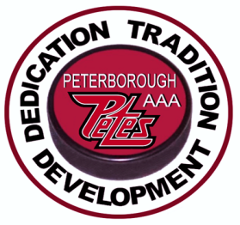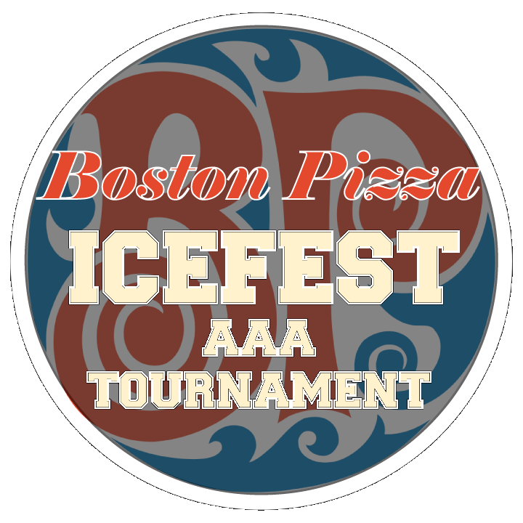

2021 Boston Pizza Icefest Tournament

Peterborough, Ontario
October 14-17, 2021
The "Boston Pizza Icefest Tournament" is a premier AAA tournament.
Over the years, many of the top ranked AAA teams from Ontario and the U.S. have competed in this tournament, which will showcase some of the best talent minor hockey has to offer.
PLEASE REGISTER NOW AND JOIN US IN OCTOBER
* O.M.H.A. sanctioned ‘AAA’ tournament
* Sponsored by Peterborough Minor Hockey Council
And the Peterborough Lions Club
U12 teams (2010’s)
U13 teams (2009’s)
U14 teams (2008’s)
U15 teams (2007’s)
* 5 games guaranteed - 7 maximum
* Entry Fee - $ 2250.00
* Scheduling priority- play teams other than in your league
* 1x10, 2x15 periods for round robin, Quarters, Semis & Finals 3x15 periods.
Overtime will decide all games.
Top Scorer awards.
MVP Awards presented in the Championship and Consolation Finals.
All teams start round-robin play on Thursday (beginning at 1:00 p.m.).
Quarter-finals start Saturday evening.
Semifinals, Consolation, and Championship Finals on Sunday.
For more information and registration form please visit the tournament web-site at:
https://peterboroughminorpetes.ca/Tournaments/1522/2021-2022_Boston_Pizza_Icefest/
Tournament Director: Frank Curran – petestourny@gmail.com

